For Immediate Release
Subject Line: CHIC DREAM-POP BAND LEMOLO TO PLAY IN TACOMA

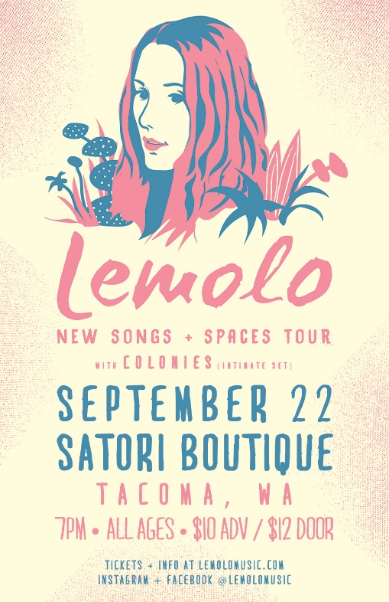
Lemolo is a celebrated indie rock band from Seattle, WA that has played sold out shows across the United States and Europe. Led by vocalist and songwriter Meagan Grandall on the keys and guitar, and supported by Adrian Centoni on the drums, the duo is known for their energy, edge, and ethereal beauty. While they’ve drawn comparisons to bands such as Cat Power, Beach House, and Warpaint, Lemolo’s growing buzz comes from a fresh and distinct tone that is truly their own. Seattle Magazine named them one of the “Best Seattle Bands” while City Arts Magazine voted them as the “Best New Band”. As part of their “New Songs & Spaces” tour, Lemolo will be unveiling their latest songs on their forthcoming album in unique and intimate settings along the west coast.
“Heavenly harmonies” – The Seattle Times
“Impressive dreamy soundscapes” – KEXP 90.3 FM
“Sonically and melodically brilliant” – Seattle Music Insider

LEMOLO AT SATORI BOUTIQUE with Colonies
September 22nd
7pm / All Ages
$10 Advance / $12 Door
1734 Pacific Ave. Tacoma, WA 98402
Tickets available at http://bit.ly/NewSongsandSpacesTacoma.
For inquiries or press passes to the show, please email lemolomusic@gmail.com. For more info about the band and to see their latest music videos, please visit lemolomusic.com.

